**Practical No. 18: Write a program to insert and retrieve data from database using JDBC**

**X.**

**1. Write a program to create a student table in database and insert a record in student table.**

import java.sql.*;

public class pract18_X1

{

    private static final String url = "jdbc:mysql://localhost:3306/dbtest";

    private static final String username = "root";

    private static final String pasword = "ksp1303@@##ok";

    public static void main(String[] args)

    { try

    {Class.forName("com.mysql.jdbc.Driver");

        Connection c =  DriverManager.getConnection(url, username, pasword);

        Statement s = c.createStatement();

        String q = String.format("INSERT INTO dbtest.student_table(RollNo , Name, Percent) VALUES(%d , '%s' , %f )" ,1333  , "Sahil" , 94.98);

        s.executeUpdate(q);

        System.out.println("Connection successful");

    }

    catch(Exception e)

    {e.printStackTrace();

    }   }

}

**Command Prompt Output:**

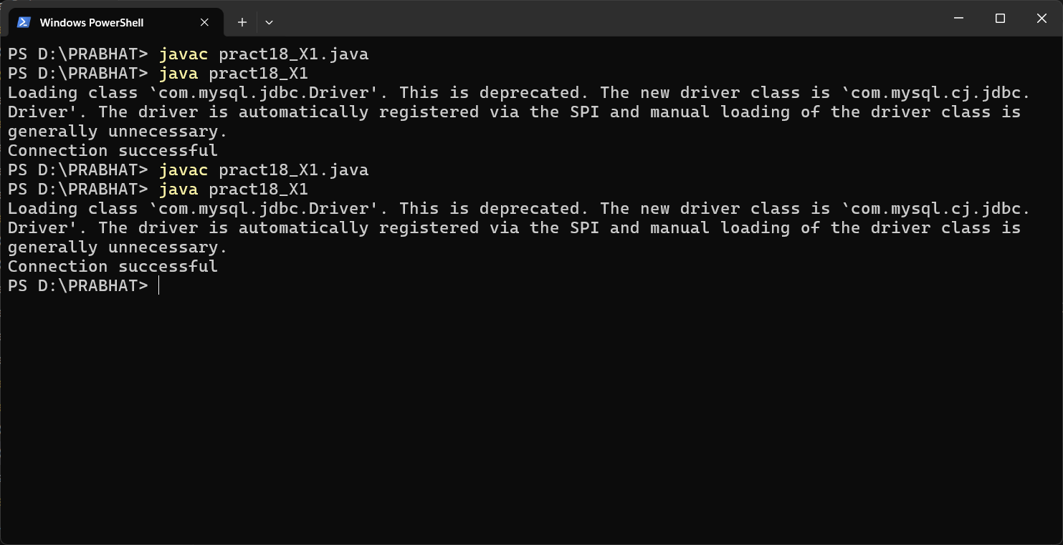

**MYSQL Command Line Client:**

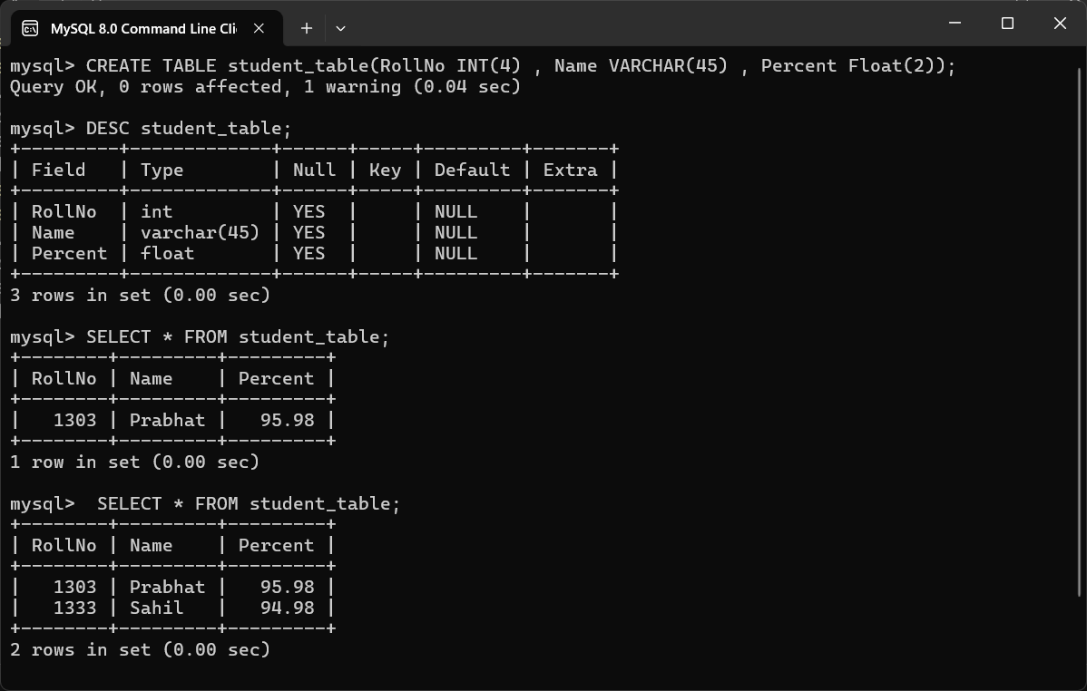

**XIII. Exercise**

1. **Develop a program to create a employee table in database having two columns “emp_id” and “emp_name”.**

**Program:**

import java.sql.*;

public class pract18_ex1

{private static final String url = "jdbc:mysql://localhost:3306/dbtest";

private static final String username = "root";

private static final String pasword = "ksp1303@@##ok";

public static void main(String[] args)

{try

{Class.forName("com.mysql.cj.jdbc.Driver");

Connection c = DriverManager.getConnection(url, username, pasword);

Statement s = c.createStatement();

String q = String.format("CREATE TABLE dbtest.employee(emp_id INT(4) , emp_name VARCHAR(60))");

String q2 = String.format("INSERT INTO dbtest.employee(emp_id , emp_name) VALUES(%d , '%s')" , 1303 , "Prabhat");

s.executeUpdate(q);

s.executeUpdate(q2);

System.out.println("Connection successful");

}

catch(Exception e)

{e.printStackTrace();

} }}

**Before Creating a table:**

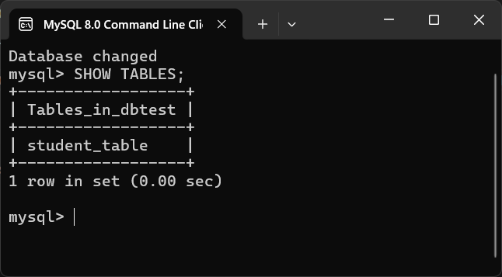

**After Creating a table:**

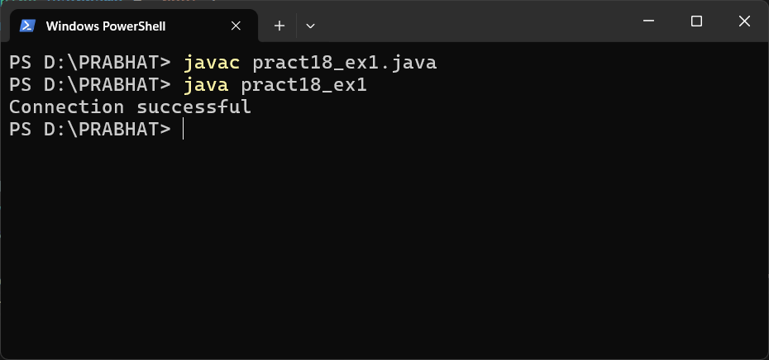

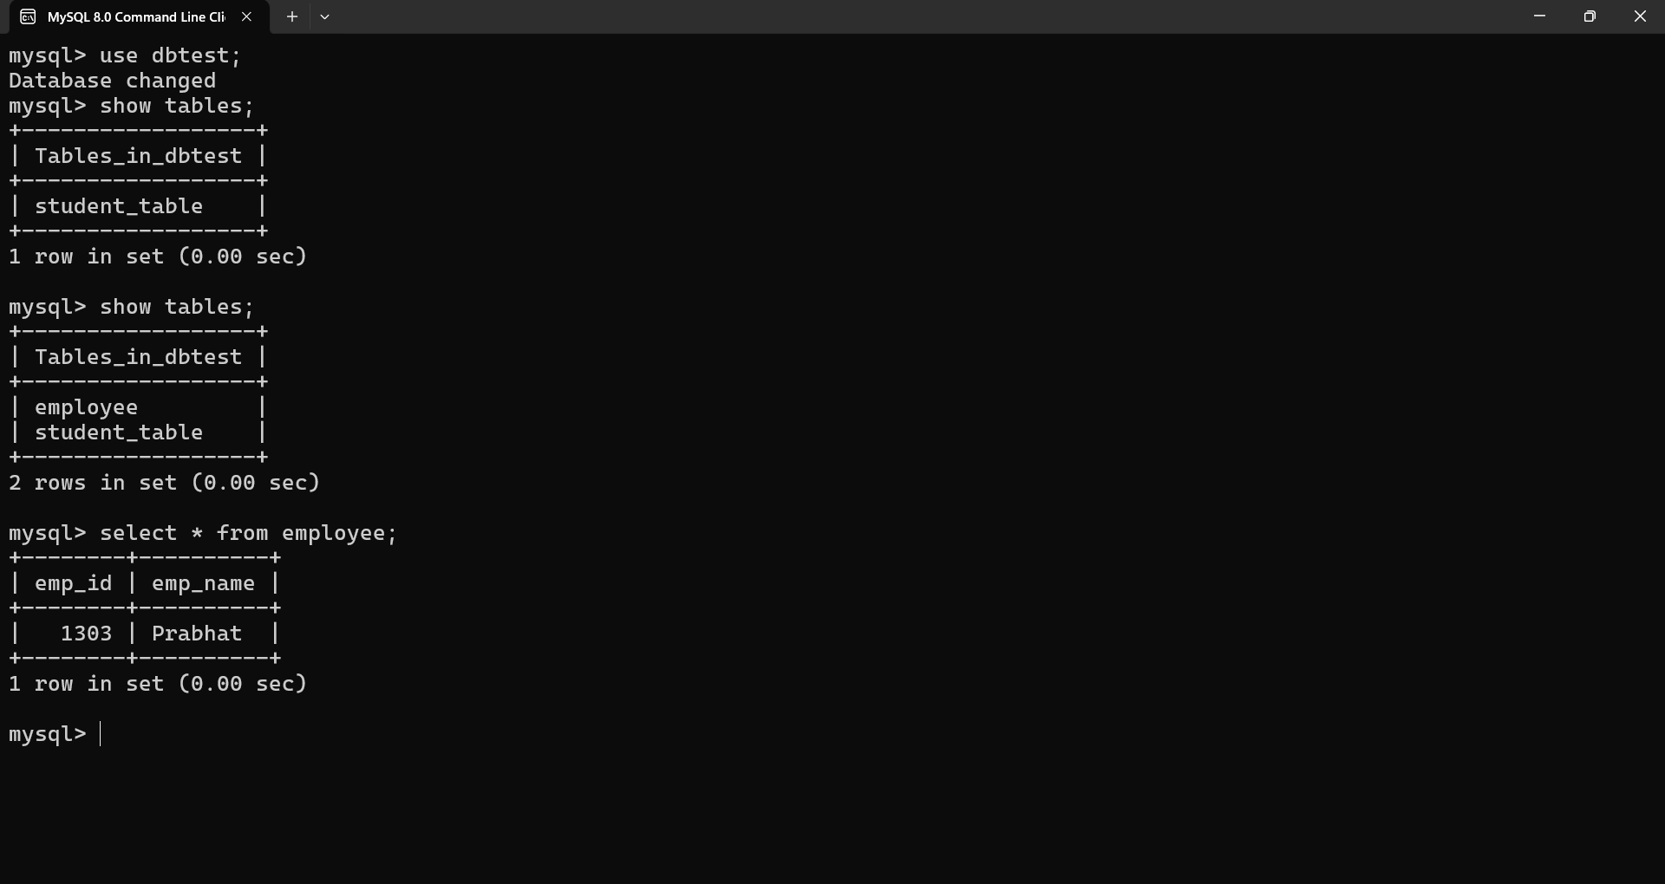

1. **Develop a program to display the name and roll_no of students from student table having percentage >70.**

**Program:**

import java.sql.*;

public class pract18_ex2

{private static final String url = "jdbc:mysql://localhost:3306/dbtest";

    private static final String username = "root";

    private static final String pasword = "ksp1303@@##ok";

    public static void main(String[] args)

    {try{

        Class.forName("com.mysql.cj.jdbc.Driver");

         Connection connection = DriverManager.getConnection(url, username, pasword) ;

Statement statement = connection.createStatement();

 String query = "Select RollNo,Name from dbtest.student_table where Percent > 70.0";

         ResultSet resultSet = statement.executeQuery(query);

         // Printing the table

while(resultSet.next())// Return boolean value 1.True if rows are remaining 2.false if rows are not remaining

         {int r = resultSet.getInt("RollNo");

String n = resultSet.getString("Name");

System.out.print("Roll No:" + r + " Name:" + n );

 System.out.println("\n");

}}catch(Exception e)

        {

         e.printStackTrace();}}}

**Database:**

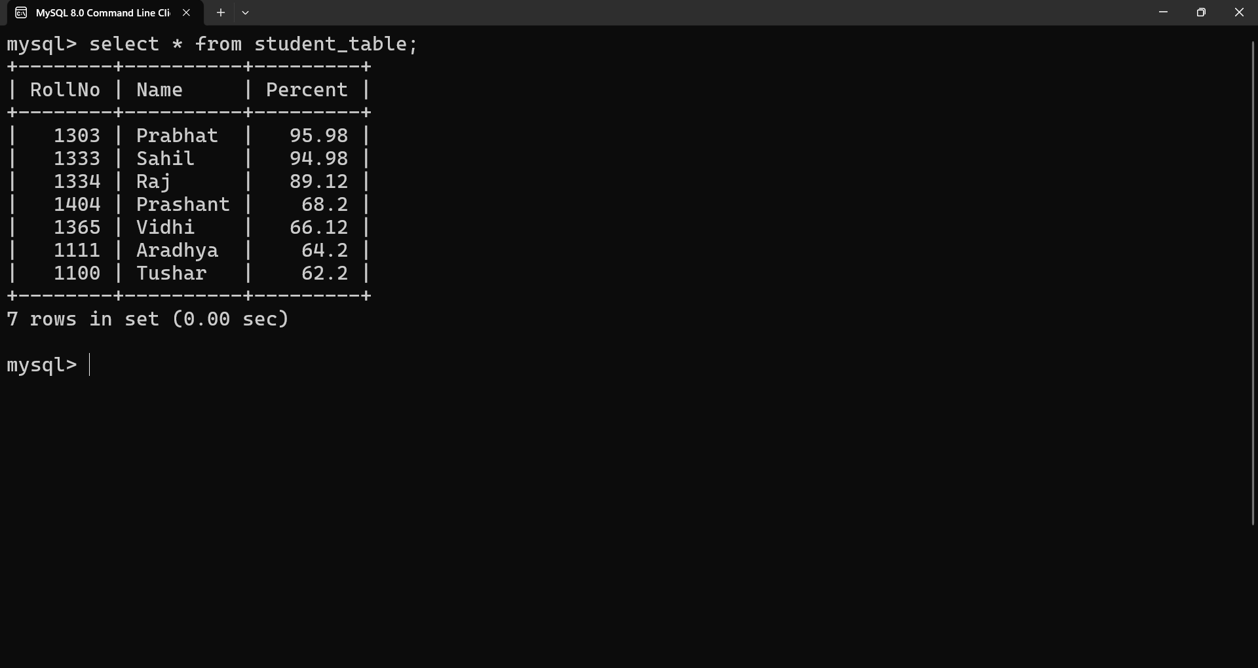

**Students with percent greater than 70:**

